CHAPTER 5
SYSTEM DESIGN
5.1 SYSTEM ARCHITECTURE
The system follows a three-tier client-server architecture. The input layer captures live hand gestures via webcam. The frontend (React.js) handles the user interface and sends frames to the Python Flask backend. The backend performs hand detection using MediaPipe, gesture classification using TensorFlow/Keras, and text-to-speech conversion using gTTS. All session data is stored in an SQLite/MySQL database.

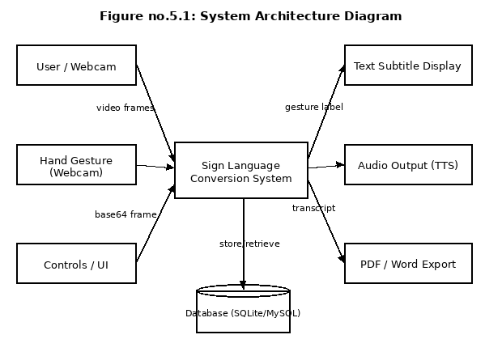
Figure no.5.1: System Architecture Diagram

5.2 ER DIAGRAM
The Entity-Relationship Diagram shows the seven database entities and the relationships between them. The sessions entity is central, linked to users (1:M), translations (1:M), transcripts (1:1), and documents (1:M). The gesture_labels entity provides the label mapping for all translation events.

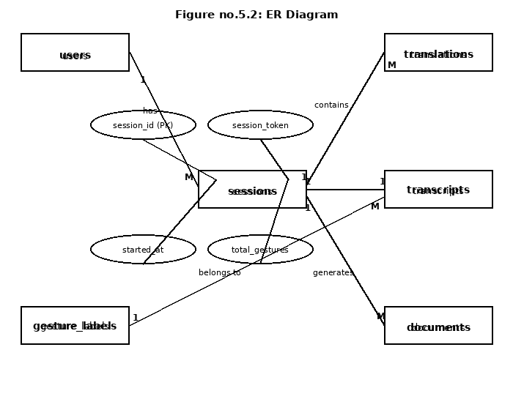
Figure no.5.2: ER Diagram

5.3 DATA FLOW DIAGRAM
5.3.1 Level 0 — Context Diagram
The Level 0 DFD represents the entire system as a single process. It shows all external entities: the Deaf/Mute User who inputs gestures, the Hearing Person who receives audio and subtitle output, Google TTS API which generates speech, and the Database which stores all session data.

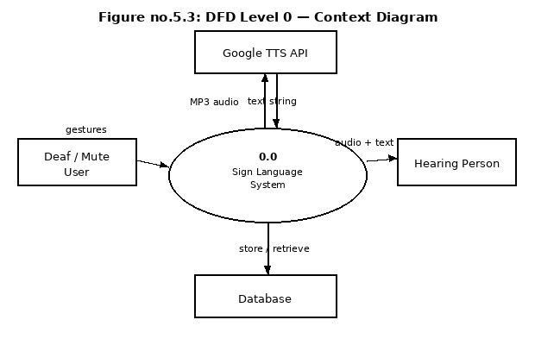
Figure no.5.3: DFD Level 0 — Context Diagram

5.3.2 Level 1 Diagram
The Level 1 DFD expands the system into five core processes: (1.0) Capture Gesture captures video frames from the webcam; (2.0) Detect Hand extracts 21 hand landmark coordinates using MediaPipe; (3.0) Recognize Gesture classifies the landmarks into a gesture label; (4.0) Generate Output assembles the text and produces TTS audio; (5.0) Export Document creates PDF or Word transcripts.

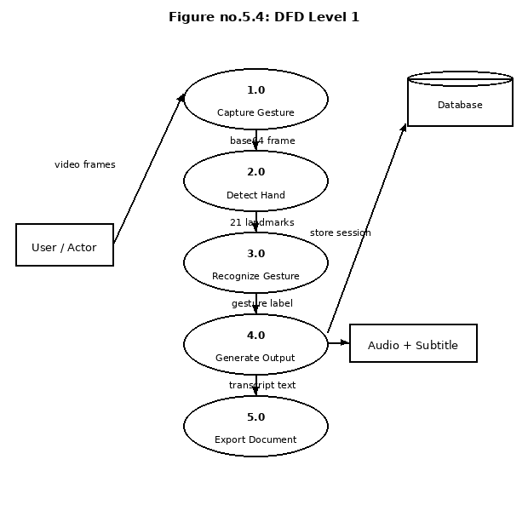
Figure no.5.4: DFD Level 1 Diagram

5.4 USE CASE DIAGRAM
The Use Case Diagram shows the interactions between actors and the system. The Deaf/Mute User can start a session, perform gestures, view subtitles, hear audio, and export documents. The Hearing Person receives audio and subtitle output. The Admin/Developer manages model training and system monitoring.

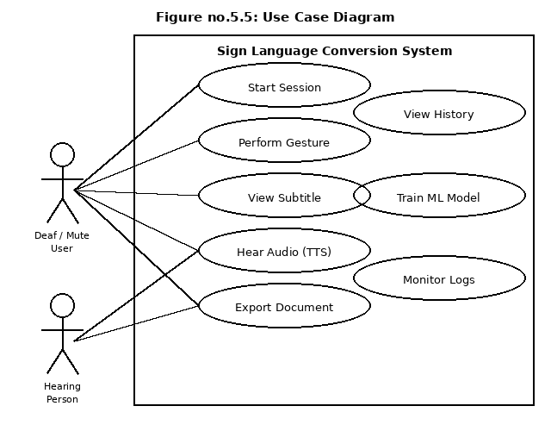
Figure no.5.5: Use Case Diagram

5.5 CLASS DIAGRAM
The Class Diagram shows the four main software classes and their relationships. GestureCapture sends frames to HandDetection. HandDetection passes landmark data to GestureRecognition. GestureRecognition passes the classified label to AudioOutput, which generates speech and exports documents.

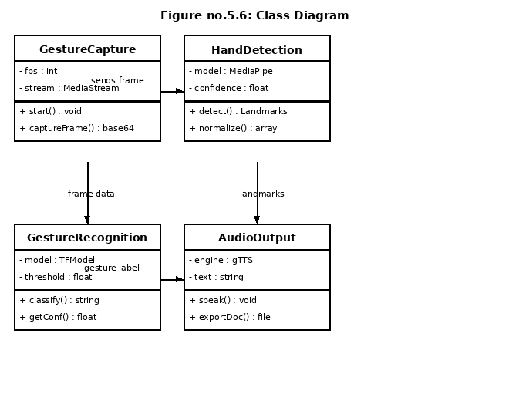
Figure no.5.6: Class Diagram

5.6 ACTIVITY DIAGRAM
The Activity Diagram shows the step-by-step flow of the system. After opening the webcam, frames are captured and landmarks are detected. The gesture is classified and passed through a confidence decision (>= 80%). If accepted, the subtitle is displayed and audio is generated. The session is then saved to the database.

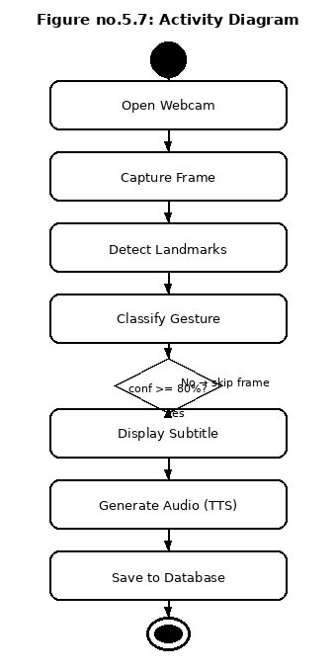
Figure no.5.7: Activity Diagram

5.7 COLLABORATION DIAGRAM
The Collaboration Diagram shows the numbered sequence of messages between system components. The User sends gesture video to the UI (React), which sends a base64 frame to Flask API. Flask decodes the frame and sends it to MediaPipe, which extracts 21 landmarks and passes them to TF/Keras. The classified label goes to TTS Engine, then to Audio Output. The session is stored in the Database.

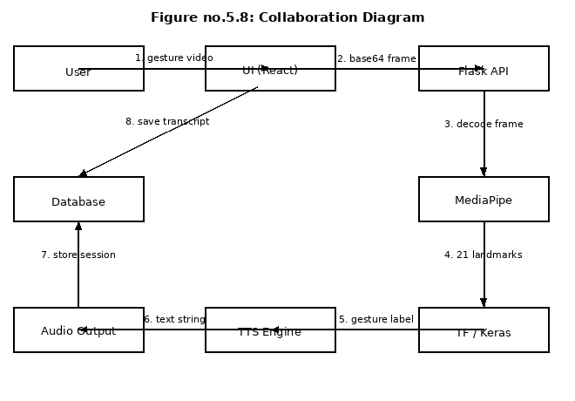
Figure no.5.8: Collaboration Diagram

5.8 DATABASE DESIGN
The database is designed in Third Normal Form (3NF) using SQLite for development and MySQL for production. SQLAlchemy ORM is used for all database operations. The schema consists of seven tables as described below.

Table: users
Field Name | Data Type | Size | Key | Description
user_id | INTEGER | 4 | Primary Key | Unique user identifier (auto-increment)
username | VARCHAR | 50 | Not Null | User chosen display name
email | VARCHAR | 100 | Unique | Email address used for login
password_hash | VARCHAR | 255 | Not Null | Bcrypt hashed password string
created_at | DATETIME | - | Not Null | Timestamp when account was created
is_active | BOOLEAN | 1 | Default True | Soft delete flag (False = deactivated)

Table: gesture_labels
Field Name | Data Type | Size | Key | Description
label_id | INTEGER | 4 | Primary Key | Unique gesture label identifier
class_index | INTEGER | 4 | Unique | ML model output class index (0, 1, 2...)
label_name | VARCHAR | 50 | Unique | Gesture label name (A, B, HELLO, etc.)
label_type | VARCHAR | 20 | Not Null | Type: alphabet, word, or phrase
description | TEXT | - | Nullable | Optional description of the gesture

Table: sessions
Field Name | Data Type | Size | Key | Description
session_id | INTEGER | 4 | Primary Key | Unique session identifier
user_id | INTEGER | 4 | Foreign Key | Linked user ID (nullable for guests)
session_token | VARCHAR | 100 | Unique | UUID token for browser session tracking
started_at | DATETIME | - | Not Null | Session start timestamp
ended_at | DATETIME | - | Nullable | Session end timestamp (null if active)
total_gestures | INTEGER | 4 | Default 0 | Total gestures recognized in session

Table: translations
Field Name | Data Type | Size | Key | Description
translation_id | INTEGER | 4 | Primary Key | Unique translation event identifier
session_id | INTEGER | 4 | Foreign Key | Session this translation belongs to
label_id | INTEGER | 4 | Foreign Key | Recognized gesture label reference
confidence_score | FLOAT | 4 | Not Null | ML model confidence score (0.0 to 1.0)
recognized_at | DATETIME | - | Not Null | Timestamp of the recognition event

Table: transcripts
Field Name | Data Type | Size | Key | Description
transcript_id | INTEGER | 4 | Primary Key | Unique transcript identifier
session_id | INTEGER | 4 | Foreign Key | One transcript per session (unique)
full_text | TEXT | - | Not Null | Complete accumulated text of the session
word_count | INTEGER | 4 | Default 0 | Total word count in the transcript
updated_at | DATETIME | - | Not Null | Timestamp of most recent update

Table: documents
Field Name | Data Type | Size | Key | Description
document_id | INTEGER | 4 | Primary Key | Unique document export identifier
session_id | INTEGER | 4 | Foreign Key | Session whose transcript was exported
transcript_id | INTEGER | 4 | Foreign Key | Transcript that was exported
format | VARCHAR | 10 | Not Null | Document format: PDF or DOCX
filename | VARCHAR | 200 | Not Null | Generated timestamped filename
downloaded_at | DATETIME | - | Not Null | Timestamp when file was downloaded

Table: system_logs
Field Name | Data Type | Size | Key | Description
log_id | INTEGER | 4 | Primary Key | Unique log entry identifier
session_id | INTEGER | 4 | Foreign Key | Related session (nullable for startup logs)
module_name | VARCHAR | 50 | Not Null | Module that generated the log entry
log_level | VARCHAR | 10 | Not Null | Severity level: INFO, WARNING, ERROR
message | TEXT | - | Not Null | Descriptive log message with event details
logged_at | DATETIME | - | Not Null | Timestamp when event was logged

